**HTML 5 Tutorials**

1. Old name of HTML 5 is WebApps 1.0.
2. In 2004, group of organizations came together to evaluate web standards and the formulated one organization – WHATWG (Started by 3 companies i.e. Apple Corp., Opera Org., Mozilla org. with the help of google they launched WHATWG). HTML 5 is the completely new HTML it has nothing common with HTML 4
3. 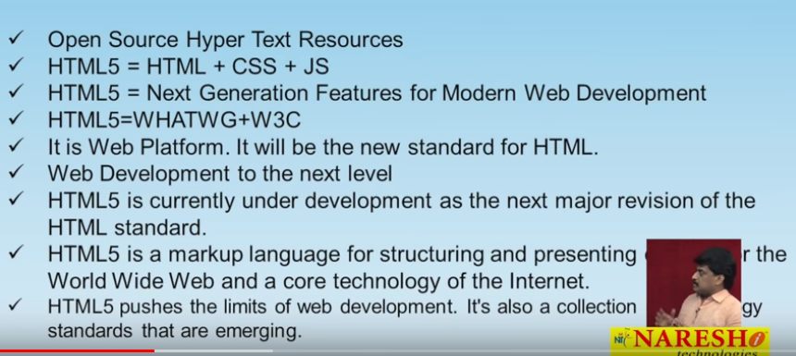
4. 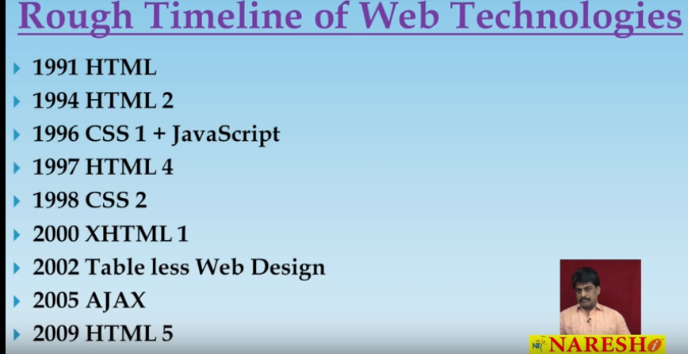
5. 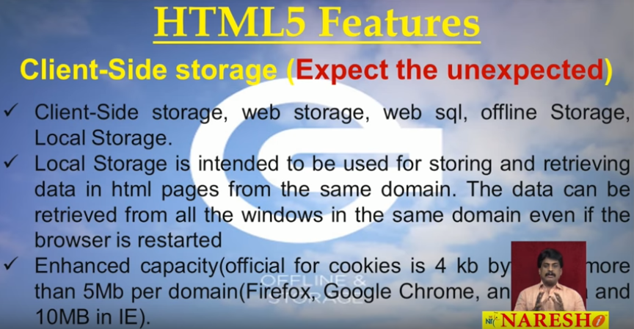
6. 
7. 
8. 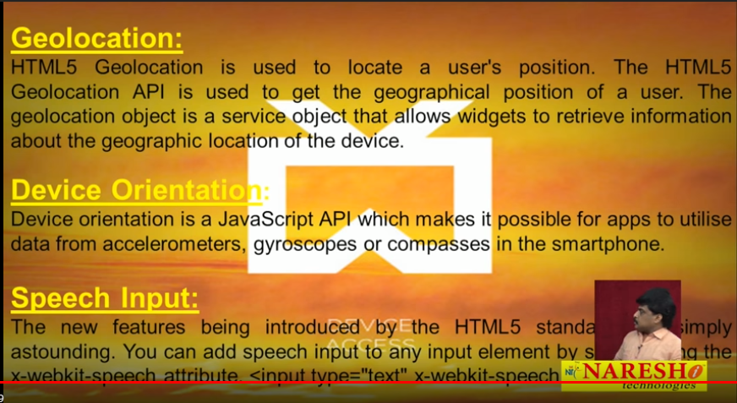
9. 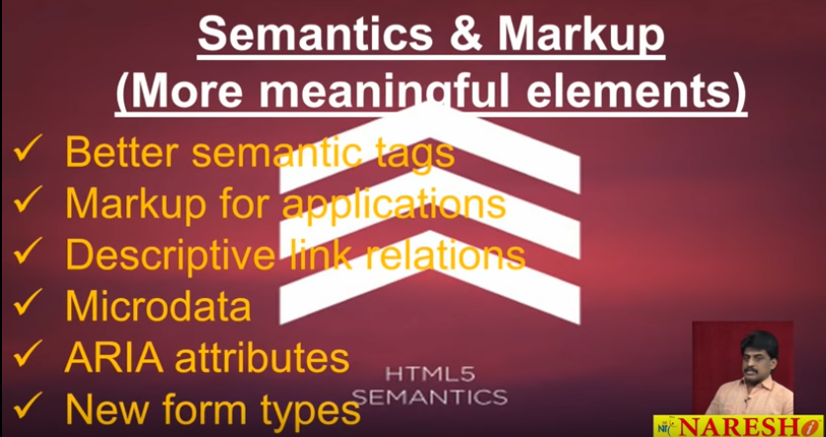
10. 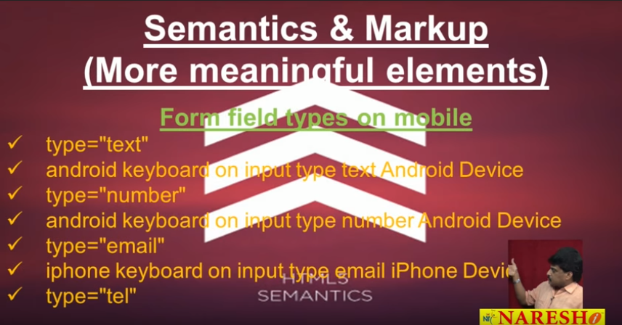
11. 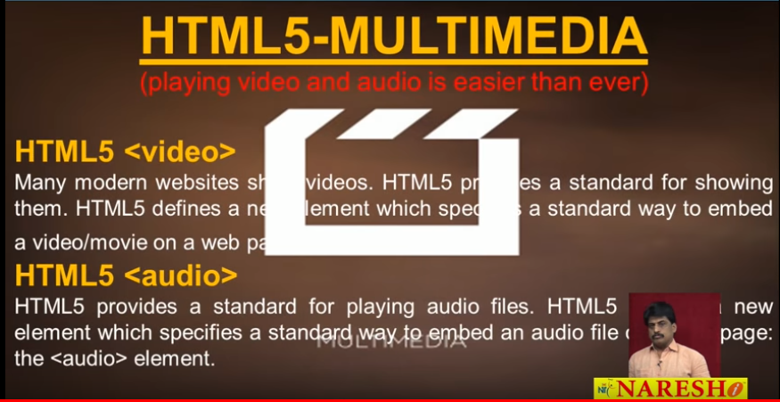
12. 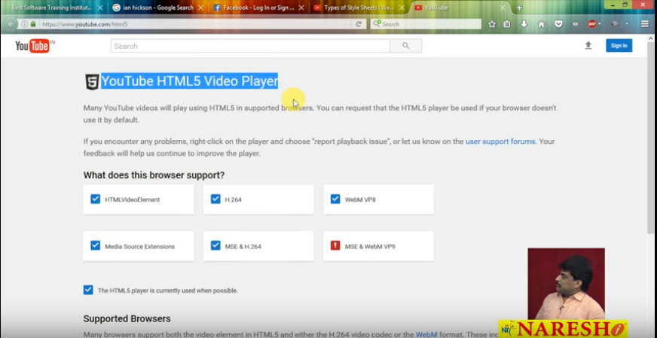
13. 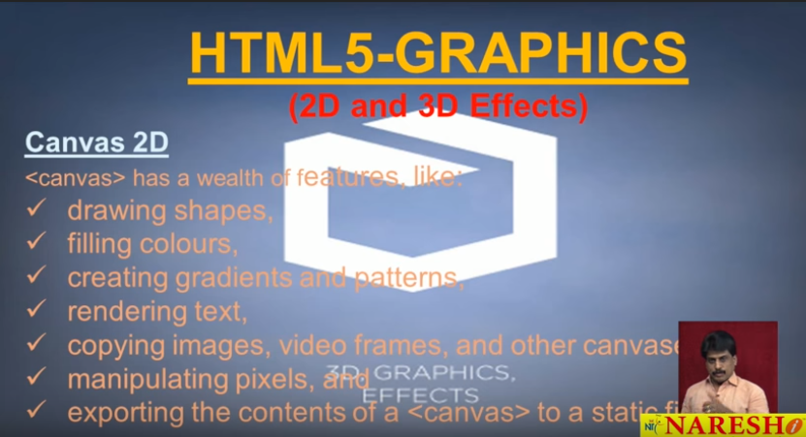
14. 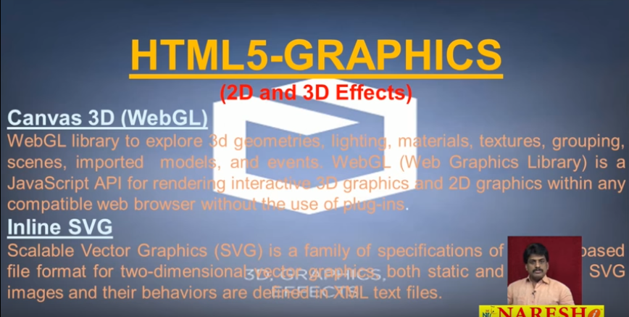
15. 
16. 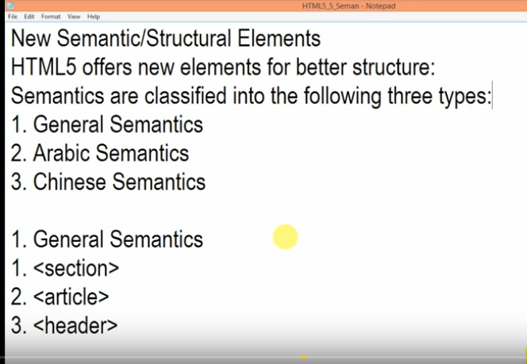
17. 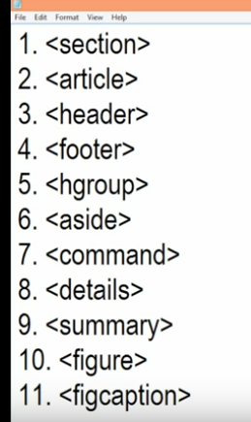
18. 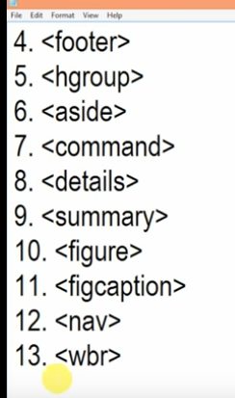
19. <section></section>, section tag is generally used for e-newspaper designing purpose. Body contains n number of sections; sections contain n number of articles; articles contain n number of paragraphs.
20. 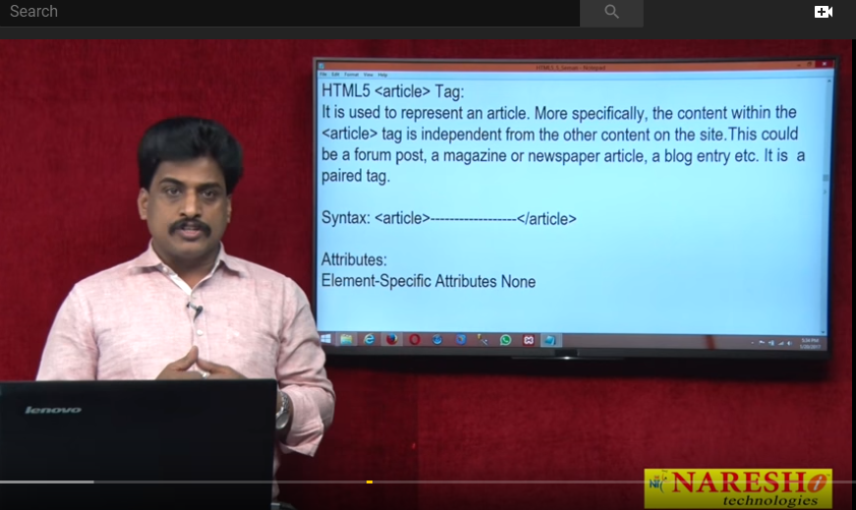
21. 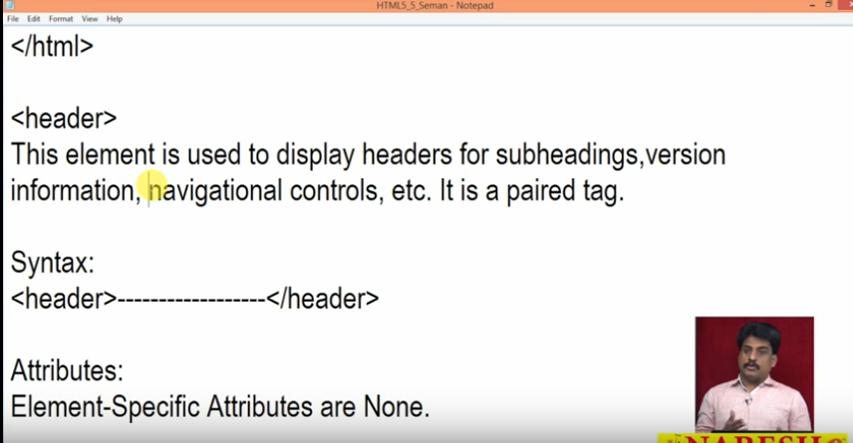
22. 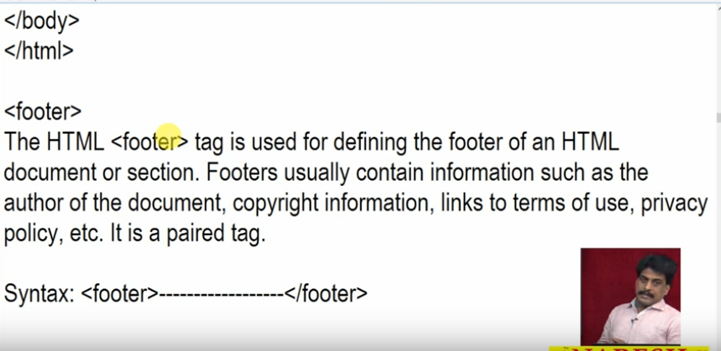
23. 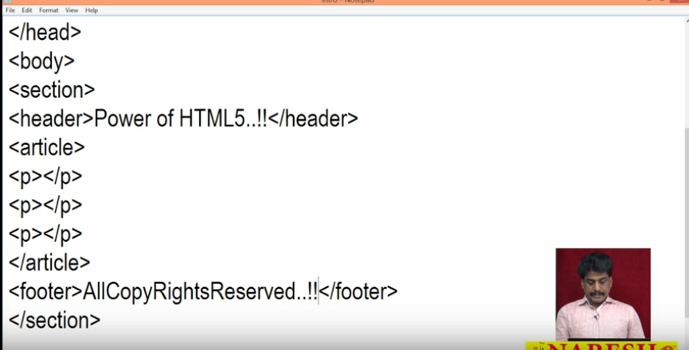
24. 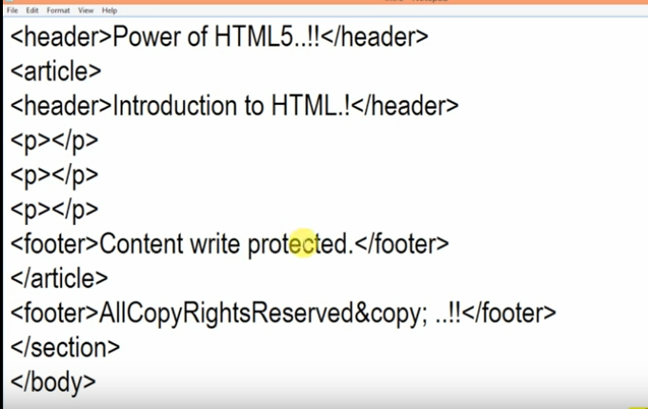
25. Above all semantics are used for the better structure.
26. We should write all the heading i.e. <h1> to <h6> all in the tag <hgroup>
27. <aside> tag can be used to shift the text left or write, examples will be displayed later.
28. 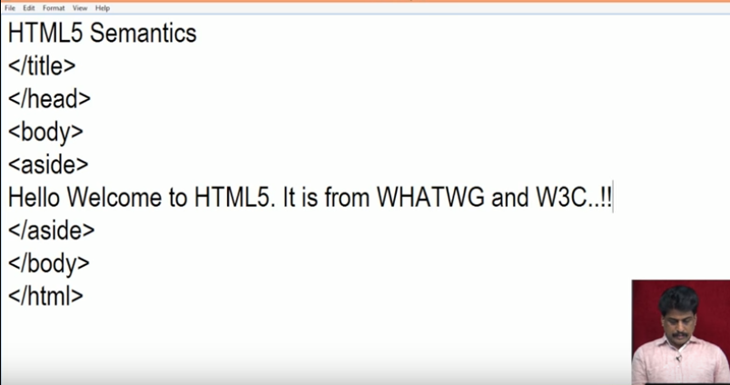
29. 